Strand 5 Yeast Experiment

A group of students wrote the following procedure for their experiment.
Procedure:
- Place 35 ml of 25% molasses solution into three small collection tubes.
- Place 1 ml of the yeast suspension into each collection tube.
- Place your palm over a small collection tube and mix each suspension well.
- Carefully slide a larger tube down over the smaller tube. Invert the tube. Repeat for each tube.
- Measure the height of the bubbles in the smaller tubes and record.
- Place on tube at 10°C in a refrigerator. Leave the second one out at room temperature at 25°C.
Place the third tube in a warming oven at 35°C. Make sure all tubes are in the dark and in an undisturbed location. Leave the three samples for 24 hours.
- Measure the change in bubble size after 24 hours. Record the data.

The table below shows the results of the group’s experiment:
Temperature  (in °C) | Height of CO2 Bubble (in mm)
10 | 2
25 | 8
35 | 10

- What conclusions can be drawn from the students’ experiment and results?
- Describe two ways the students could have improved their experimental design and/or validity of their results.

Rubric for Yeast Experiment - Possible Correct Responses:

Conclusions:
- CO2 production in yeast increases with increasing temperature.
- CO2 production in yeast decreases with decreasing temperature.

Improvements:
- The students could repeat the experiment to verify their results or do multiple trials at each
temperature and average their results.
- The students could add additional trials at higher (and/or lower) temperatures to see if the trend
holds.
- The students could perform the test again at smaller temperature increments.
- The students could use a warming oven for the test tube subjected to room temperature (25°C), because in 24 hours, temperatures could fluctuate a few degrees which could affect results.
- The students should use a consistent size for the gas collection tube (not clear in procedure).
- Other acceptable responses.

3-Point Rubric:

Score 3
The response provides a valid conclusion and describes at least two ways the students could improve
their experimental design and/or the validity of their results.

Score 2
The response provides a valid conclusion and describes one way the students could improve their
experimental design and/or the validity of their results.
-or-
The response describes at least two ways the students could improve their experimental design and/or
the validity of their results but fails to provide a valid conclusion.

Score 1
The response provides a valid conclusion but fails to accurately describe a way the students could
improve their experimental design and/or the validity of their results.
-or-
The response describes one way the students could improve their experimental design and/or the validity of their results but fails to provide a valid conclusion.

Score 0
The response describes little or no accurate or relevant information.

Sample Student Responses

Response #1 (3)
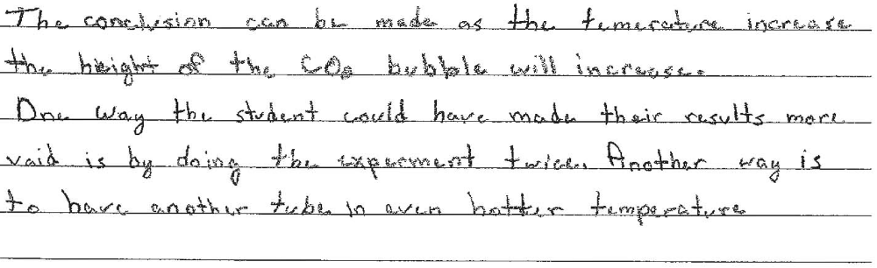

Response #2 (2)
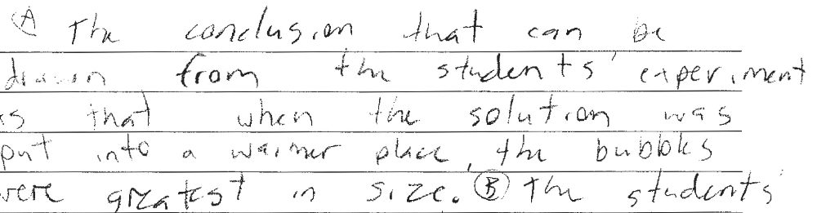
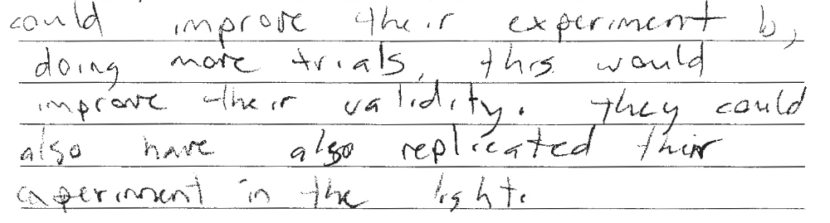

Response #3 (1)
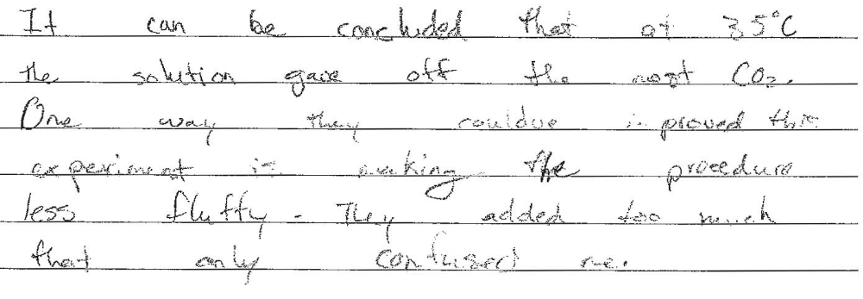

Response #4 (0)
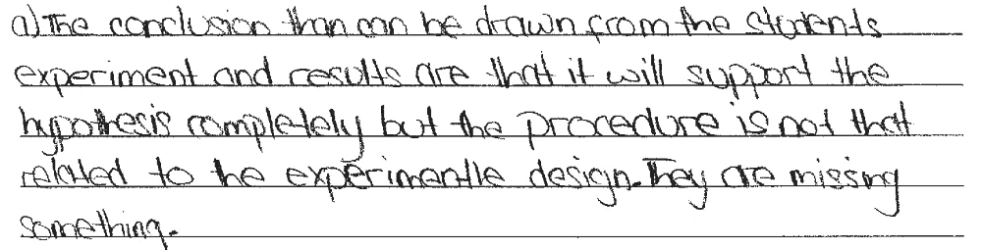
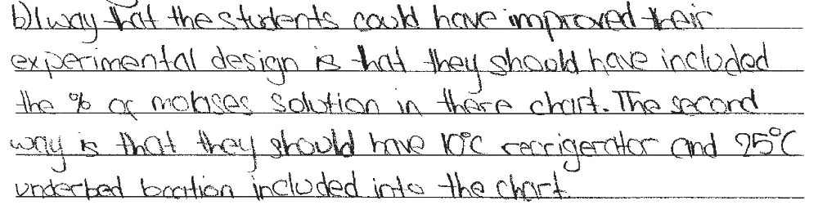

Response #5 (1)
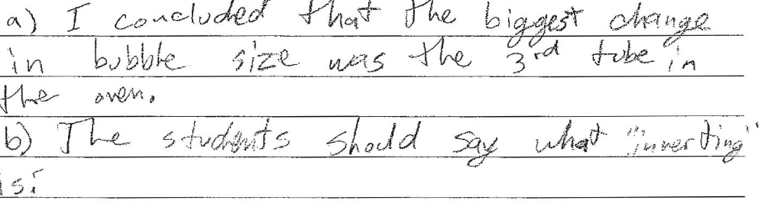

Response #6 (3)


